A Review of Low-Cost Tool-Condition Monitoring Methods for CNC Machine Tools
Odilbek Marimov
Department of Mechanical Engineering, New Uzbekistan University, Tashkent, Uzbekistan
odilbekmarimov70@gmail.com
Abstract — Tool wear in computer numerical control (CNC) machining degrades surface quality, dimensional accuracy, and process safety, and unplanned tool failure is a major source of downtime and scrap. Tool-condition monitoring (TCM) aims to estimate tool health automatically so that tools are changed neither too early nor too late. This paper reviews TCM methods for CNC machine tools with particular attention to low-cost approaches suitable for small and medium-sized enterprises (SMEs). Monitoring strategies are first classified into direct methods, which measure wear geometry, and indirect methods, which infer tool state from auxiliary signals such as cutting force, vibration, acoustic emission, motor current, and sound. The indirect monitoring pipeline—signal acquisition, pre-processing, feature extraction in the time, frequency, and time–frequency domains, feature selection, and decision-making—is then reviewed, followed by the shift from fixed thresholds to classical machine learning, deep learning, and multi-sensor fusion. Current- and audio-based sensorless techniques are highlighted as practical, inexpensive, and non-intrusive options for SME retrofits. The review concludes by identifying open challenges, including robustness to varying machining conditions, limited and imbalanced data, and deployment cost.
Keywords: tool condition monitoring; CNC machining; tool wear; indirect monitoring; sensor fusion; machine learning
1. Introduction
Machining remains one of the most widely used manufacturing processes, and the cutting tool is the component that most directly determines part quality. As a tool wears, cutting forces rise, vibration increases, surface roughness deteriorates, and dimensional tolerances drift; in the worst case the tool fractures, damaging the workpiece and the machine. In automated CNC environments, where human supervision is limited, the ability to assess tool condition automatically is therefore essential for productivity, quality, and safety [1], [2].
Conventional practice replaces tools on conservative fixed schedules. This wastes tool life when tools are discarded prematurely and risks scrap and downtime when they are used beyond their useful life. Tool-condition monitoring (TCM) addresses this by estimating tool state online from measured signals, enabling condition-based tool changes [3]. While advanced TCM is established in high-value aerospace and automotive production, its uptake among small and medium-sized enterprises (SMEs) is limited by sensor and integration cost [2]. This motivates the present review's emphasis on low-cost, retrofittable methods.
This paper surveys TCM methods for CNC machine tools. Section 2 reviews tool wear and the motivation for monitoring. Section 3 classifies monitoring approaches. Section 4 examines sensor modalities, Section 5 the signal-processing and feature-engineering pipeline, and Section 6 the decision-making stage. Section 7 focuses on low-cost TCM for SMEs, Section 8 discusses open challenges, and Section 9 concludes.
2. Tool Wear and the Need for Monitoring
2.1 Wear mechanisms and progression
Cutting tools degrade through several coupled mechanisms—abrasion, adhesion, diffusion, and, under interrupted cuts, chipping and fracture. The most common quantitative wear measure is the width of the flank wear land, VB. Flank wear typically follows the three-region progression shown in Figure 3: an initial break-in region of rapid wear, a long steady-state region of approximately linear wear, and a final region of accelerated wear that ends in tool failure [3]. A wear criterion VB* is defined as the threshold beyond which the tool should be replaced; the goal of TCM is to detect the approach to this threshold reliably.
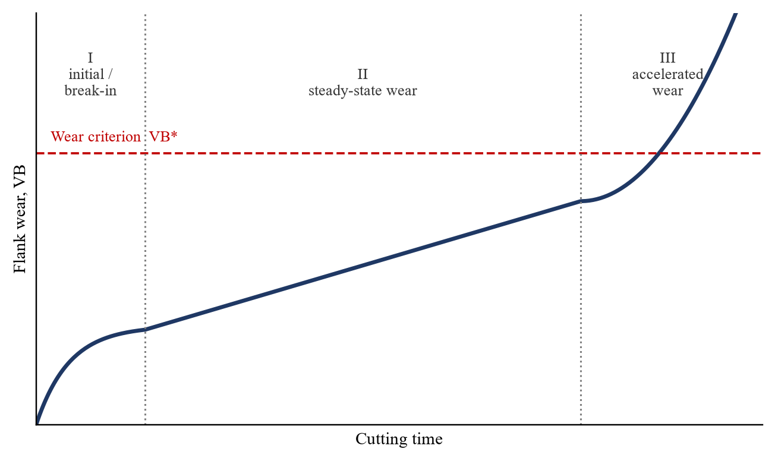
Figure 3. Conceptual progression of flank wear (VB) with cutting time, showing the three characteristic wear regions and the wear criterion VB*.
2.2 Economic and quality motivation
Because tool cost, machine downtime, and scrap are all tied to tool state, accurate monitoring has a direct economic payoff. Effective TCM extends usable tool life, reduces unplanned stoppages, stabilises surface quality, and protects the spindle and workpiece from the consequences of catastrophic failure [1], [5].
3. Classification of Tool-Condition Monitoring Methods
TCM methods are conventionally divided into direct and indirect approaches, as summarised in Figure 1. Direct methods measure tool-wear geometry itself, whereas indirect methods infer tool state from auxiliary process signals [1], [3].
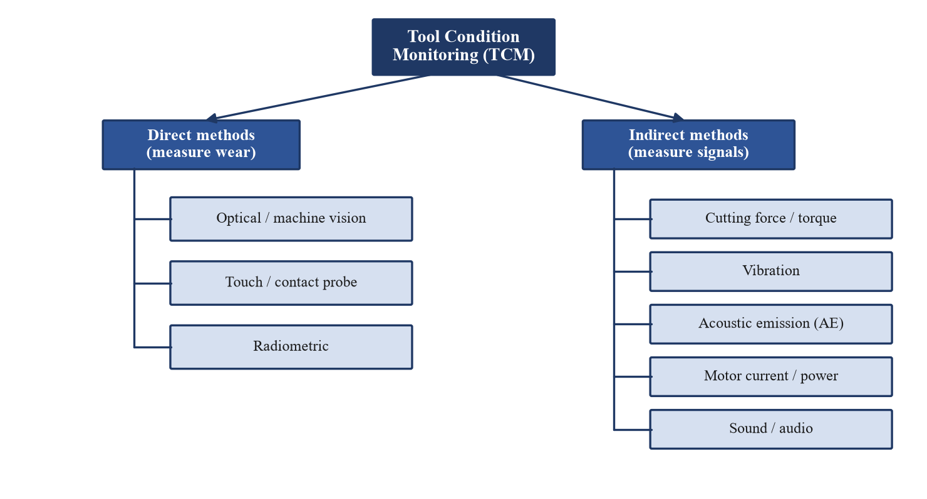
Figure 1. Classification of tool-condition monitoring methods into direct and indirect approaches and their common sensor modalities.
3.1 Direct methods
Direct methods—optical microscopy, machine vision, touch probes, and radiometric techniques—measure wear with high fidelity. However, they typically require the cut to be interrupted and the tool to be inspected, increasing downtime, and camera-based inspection demands clear optical access and controlled lighting [1], [12]. They are therefore best suited to intermittent verification rather than continuous in-process monitoring.
3.2 Indirect methods
Indirect methods correlate auxiliary signals—cutting force, torque, vibration, acoustic emission, motor current, power, and sound—with tool state, allowing continuous in-process monitoring without stopping the machine [3], [4]. The trade-off is that these signals are influenced by cutting conditions and noise, so signal processing and learning algorithms are needed to extract a reliable estimate of tool condition. Indirect monitoring dominates the recent literature and is the focus of the remainder of this review.
4. Sensor Modalities for Indirect Monitoring
Table 1 compares the principal sensor modalities used for indirect TCM in terms of sensitivity, cost, and intrusiveness.
Sensor modality | Sensitivity to wear | Relative cost | Intrusiveness | Notes
Cutting force / dynamometer | High | High | Intrusive (fixturing) | Strong correlation; costly and hard to retrofit
Vibration / accelerometer | Moderate–high | Low | Easy retrofit | Popular; affected by structural dynamics
Acoustic emission (AE) | High | Moderate | Sensor placement | Wide bandwidth, very sensitive; noise-prone
Motor current / power | Moderate | Very low | Non-intrusive | Sensorless; ideal low-cost option for SMEs
Sound / microphone | Moderate | Very low | Non-intrusive | Cheap; sensitive to ambient noise
Machine vision / camera | Direct (wear) | Moderate | Needs clear view / pause | Bridges direct and indirect approaches
Table 1. Comparison of common sensor modalities for indirect tool-condition monitoring.
4.1 Cutting force and torque
Cutting force and torque correlate strongly with flank wear and are widely regarded as among the most reliable indicators of tool state [3], [8]. The drawback is practical: dynamometers are expensive and usually require modification of the fixturing or spindle, which limits their use outside research and high-value production.
4.2 Vibration
Accelerometers are inexpensive and easy to retrofit, making vibration one of the most popular signals for TCM. Wear changes the amplitude and spectral content of machine vibration, although the signal is also affected by the structural dynamics of the machine and fixturing [6], [7].
4.3 Acoustic emission
Acoustic emission (AE) captures high-frequency elastic waves generated by deformation and fracture in the cutting zone. Its wide bandwidth makes it highly sensitive to wear and breakage, but it is also sensitive to noise and to sensor placement, and it often benefits from wavelet-based pre-processing before feature extraction [9].
4.4 Motor current and power
Spindle and feed-drive motor current and power can be read from the machine's own drives, requiring no added sensors. This sensorless approach is non-intrusive and essentially free to deploy, which makes it especially attractive for SME retrofits, at the cost of lower sensitivity than force or AE signals [2], [5].
4.5 Sound and machine vision
Microphones offer a very low-cost, non-contact signal, and recent work applies feature selection and artificial-intelligence models to audio for wear prediction, though ambient shop noise is a challenge [11]. Machine vision, as noted in Section 3.1, measures wear directly and is increasingly combined with signal-based methods in hybrid systems [12].
5. Signal Processing and Feature Engineering
Raw sensor signals are rarely used directly. A typical indirect-TCM pipeline, shown in Figure 2, comprises signal acquisition, pre-processing, feature extraction, feature selection, and a decision model that outputs the estimated tool condition [3], [4].
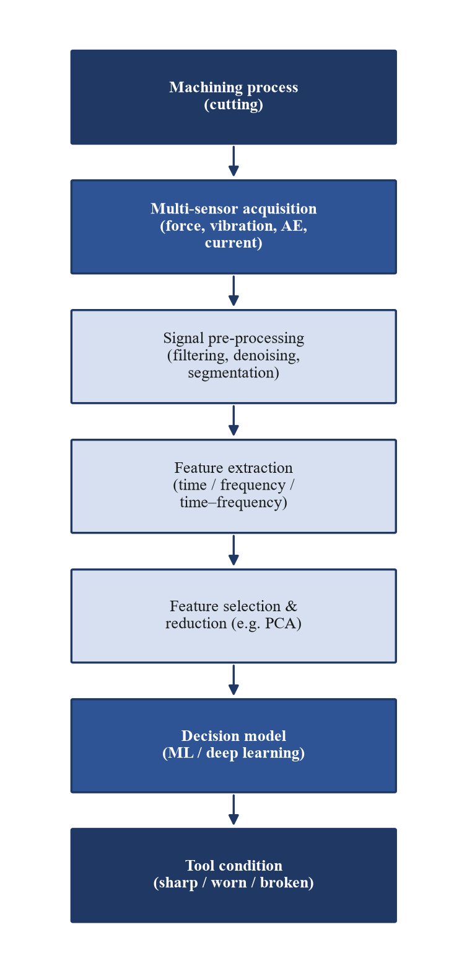
Figure 2. Generic processing pipeline for indirect tool-condition monitoring, from multi-sensor acquisition to the estimated tool state.
5.1 Feature domains
Features are extracted in three domains. Time-domain features (e.g. root mean square, variance, peak, kurtosis) are simple and fast. Frequency-domain features obtained via the Fourier transform capture spectral shifts associated with wear. Time–frequency methods, especially the wavelet transform, are well suited to the non-stationary, nonlinear signals typical of machining and are frequently applied to vibration and AE data [6], [9].
5.2 Feature selection and reduction
Extracting many features across several sensors and axes produces high-dimensional data that can contain redundancy and degrade model performance. Feature selection and dimensionality reduction—principal component analysis (PCA) being the most common—are therefore used to retain the most informative features before classification [8].
6. Decision-Making: From Thresholds to Machine Learning
6.1 Classical machine learning
Early systems compared a feature against a fixed threshold, but thresholds generalise poorly across changing cutting conditions. Classical machine-learning models—support vector machines, artificial neural networks, decision trees, and ensembles—map extracted features to tool-condition classes or to a continuous wear estimate, and remain widely used owing to their effectiveness on modest data sets [3], [6].
6.2 Deep learning
Deep models, including convolutional and recurrent neural networks, can learn features directly from signals and have achieved strong results, at the cost of larger data and computational requirements [2]. Digital-twin formulations have also been proposed to drive online wear estimation from a virtual model of the process [10].
6.3 Multi-sensor fusion
Because each modality has complementary strengths and weaknesses, fusing multiple sensors generally outperforms any single signal. Fusion can occur at the signal, feature, or decision level, and studies consistently report improved accuracy and robustness from fused inputs [7], [8].
7. Toward Low-Cost Tool-Condition Monitoring for SMEs
For SMEs, the central barrier is cost—of sensors, data-acquisition hardware, and integration—rather than algorithmic capability. Two directions are especially promising. First, sensorless monitoring from motor current and power exploits data already available in the machine's drives, eliminating added-sensor cost [2], [5]. Second, low-cost vibration and microphone sensors paired with internet-of-things (IoT) data acquisition and modern machine learning can deliver useful accuracy at a fraction of the cost of force-based systems [2], [11]. Hybrid vision-plus-signal systems further improve reliability where a camera can be accommodated [12]. Together these enable retrofittable TCM on existing, lower-end CNC equipment.
8. Challenges and Future Directions
Several challenges remain. Indirect signals depend strongly on cutting conditions, so models trained for one regime often fail to generalise to others, motivating transfer-learning and domain-adaptation methods. Labelled wear data are scarce, costly to obtain, and frequently imbalanced toward the healthy class, which complicates training [2]. Robustness to shop-floor noise, standardisation of data and evaluation, and the cost of deployment at scale are likewise open issues. Future work is likely to emphasise data-efficient and self-supervised learning, edge and IoT deployment, digital-twin integration [10], and explainable models that operators can trust.
9. Conclusions
Tool-condition monitoring is essential to safe, productive, and high-quality CNC machining. Direct methods measure wear accurately but interrupt production, whereas indirect methods enable continuous in-process monitoring by inferring tool state from auxiliary signals. Across the literature, cutting force and acoustic emission offer the highest sensitivity, while vibration, motor current, and sound provide low-cost, retrofittable alternatives well matched to SMEs. The field has moved from fixed thresholds to classical machine learning, deep learning, and multi-sensor fusion, with consistent gains from fusion. Realising widespread, affordable TCM will depend less on new algorithms than on robustness to varying conditions, the scarcity and imbalance of wear data, and the cost of deployment—the directions most likely to define future research.
References
[1] “Tool Condition Monitoring for High-Performance Machining Systems—A Review,” Sensors, 2022. https://www.ncbi.nlm.nih.gov/pmc/articles/PMC8950983/
[2] “Machine learning and IoT-based approach for tool condition monitoring: A review and future prospects,” Measurement, 2022. https://www.sciencedirect.com/science/article/abs/pii/S0263224122015470
[3] “Tool wear intelligent monitoring techniques in cutting: a review,” Journal of Mechanical Science and Technology, 2022. https://link.springer.com/article/10.1007/s12206-022-1229-9
[4] “Research progress on intelligent monitoring of machining condition based on indirect method,” Advanced Engineering Informatics, 2025. https://www.sciencedirect.com/science/article/abs/pii/S1474034625004112
[5] “Condition Monitoring of Machine Tool Feed Drives: A Review,” ASME Journal of Manufacturing Science and Engineering, 144(10):100802, 2022. https://asmedigitalcollection.asme.org/manufacturingscience/article/144/10/100802/1140787/
[6] “Development of a tool condition monitoring system in end milling using wavelet features and Hoelder’s exponent with machine-learning algorithms,” Measurement, 2020. https://www.sciencedirect.com/science/article/abs/pii/S0263224120311830
[7] “Machine Tool Wear Prediction Technology Based on Multi-Sensor Information Fusion,” Sensors, 2024. https://pmc.ncbi.nlm.nih.gov/articles/PMC11054666/
[8] “Tool Wear Prediction in Ti-6Al-4V Machining through Multiple Sensor Monitoring and PCA Feature Pattern Recognition,” Sensors, 2018. https://www.ncbi.nlm.nih.gov/pmc/articles/PMC5876750/
[9] “A Novel Machine Learning-Based Methodology for Tool Wear Prediction Using Acoustic Emission Signals,” Sensors, 2021. https://www.ncbi.nlm.nih.gov/pmc/articles/PMC8434684/
[10] “An online monitoring method of milling cutter wear condition driven by digital twin,” Scientific Reports, 2024. https://www.nature.com/articles/s41598-024-55551-2
[11] “AI-based tool wear prediction with feature selection from sound signal analysis,” Frontiers in Mechanical Engineering, 2025. https://www.frontiersin.org/journals/mechanical-engineering/articles/10.3389/fmech.2025.1608067/full
[12] “Tool condition monitoring in CNC systems: a hybrid computer vision and signal-processing approach,” International Journal of Advanced Manufacturing Technology, 2025. https://link.springer.com/article/10.1007/s00170-025-17051-z

Working manuscript draft prepared June 2026

